Title [centred, Heading 1, Arial 14 Bold, before 12pt, after 0pt]

Name(s) FamilyName(s) [centred, Heading 2, Arial 12 Bold-Italic, before 6pt, after 0pt] – please provide full names, not only initials
Institution, Country [centred, Normal, Arial 11, before 6pt, after 0pt] – universities, large research institutions... please use the format: Department, University, Country
e-mail: corresponding@author [centred, Normal, Arial 11, before 0pt, after 0pt]
The entire document should be in Arial and single line spacing. Paper must use a page size A4 (21cm wide and 29.7cm long). The margins must be set as follows: top – 2.54 cm; left/right – 2.25 cm; bottom: 2 cm; footer – 1.25 cm (5th International Conference “Riga and Photonics 2023”, April 20 - 21, 2023, Riga, Latvia). All paragraphs must be justified alignment, Arial 11, First line 0.5cm; for first paragraph: before 12pt, after 0pt, for the rest of text: before 0pt, after 0pt
Total lengths of the pre-conference Abstract: 1-2 pages. After the Conference an Abstract booklet will be published (previous issue: https://dspace.lu.lv/dspace/handle/7/56613), expected length of extended abstracts – up to 4 pages.
Subtitle [aligned left, Bold, before 6pt, after 0pt]
Text, text, text …
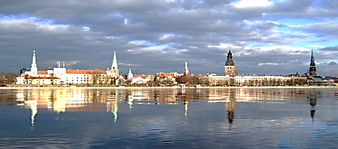
Figure 1. Title [centred, Arial 10 Italic, before 3pt, after 3pt, line spacing: single]
Table 1. Title [centred, Arial 10 Italic, before 3pt, after 3pt, line spacing: single]
date | Population | Annual Change, %
1950-12-31 | 490,000
1960-12-31 | 597,000 | 1.88
1970-12-31 | 728,000 | 2.1
1980-12-31 | 840,000 | 0.96
1989-12-31 | 909,000 - maximum | 0.44
2000-12-31 | 762,000 | -1.17
2010-12-31 | 665,000 | -1.34
2020-12-31 | 631,000 | -0.47
2035-12-31 – UN projection | 588,000 | -0.51
Acknowledgments (optional) [aligned left, Bold, before 6pt, after 0pt]
This research was … [justified, before 0pt, after 0pt]
References [aligned left, Arial 10 Bold, before 6pt, after 0pt]
Reference list should be in Arial 10. Number citations in square brackets [1]. Please follow the APA format:
[1] Familyname, N. (Year).Title of the Paper. Journal name, Volume(Number), page-page
[2] Grady, J. S., Her, M., Moreno, G., Perez, C., Yelinek, J. (2019). Emotions in storybooks. Psychology of Popular Media Culture, 8(3), 207–217
[3] NIST Atomic Spectra Database. https://www.nist.gov/pml/atomic-spectra-database

